INKOSI LANGALIBALELE MUNICIPALITY



MONTHLY BUDGET STATEMENT

DECEMBER 2023

**MONTHLY FINANCIAL PERFORMANCE DECEMBER 2023**

**1. Purpose**

To inform Council of the financial status of the municipality as at the end 31 December 2023

In accordance with Section 71 of the Municipal Finance Management Act 2003.

**2. Overview of current financial performance**

Table 1 : Operating Revenue as at the end of 31 December 2023.



The table above gives us a picture of the income generated as at the end of December 2023. Total income for the month is 36.3 million. The highest source of income is Service Charges- Electricity at 38.8 million. On overall the Operating Revenue shows 14% variance below the budgeted year-to-date amount of 377 million.

The following factors also contribute to revenue variance:

* Property Rates shows 15% below the budgeted year-to-date figure of 81.9 million mainly due to fact that the Department of Public Works made special plea after the budget was concluded that its accounts be excluded from the annual billing but rather be billed on monthly basis.
* Interest earned on external investments reflects 53% variance above the budgeted year-to-date figure of 3.9 million due to the fact that the municipality received the disaster Relief Grant of 76 Million only March and has only started spending it in April last financial year and also that a significant portion of equitable share is invested.
* Fines, Penalties and Forfeits the reason for -16% variance is mainly attributable to the fact that receipting is not done timeously.
* Licences and Permitsoverall variance of 22 % below the year-to-date budgeted figure is mainly attributable to the fact that receipts from Traffic department have not receipted timeously.
* Interest earned from Receivables recorded an overall variance of 21% above the year to date budgeted amount and that mainly attributable to low revenue collection.

**Figure 1: Income**

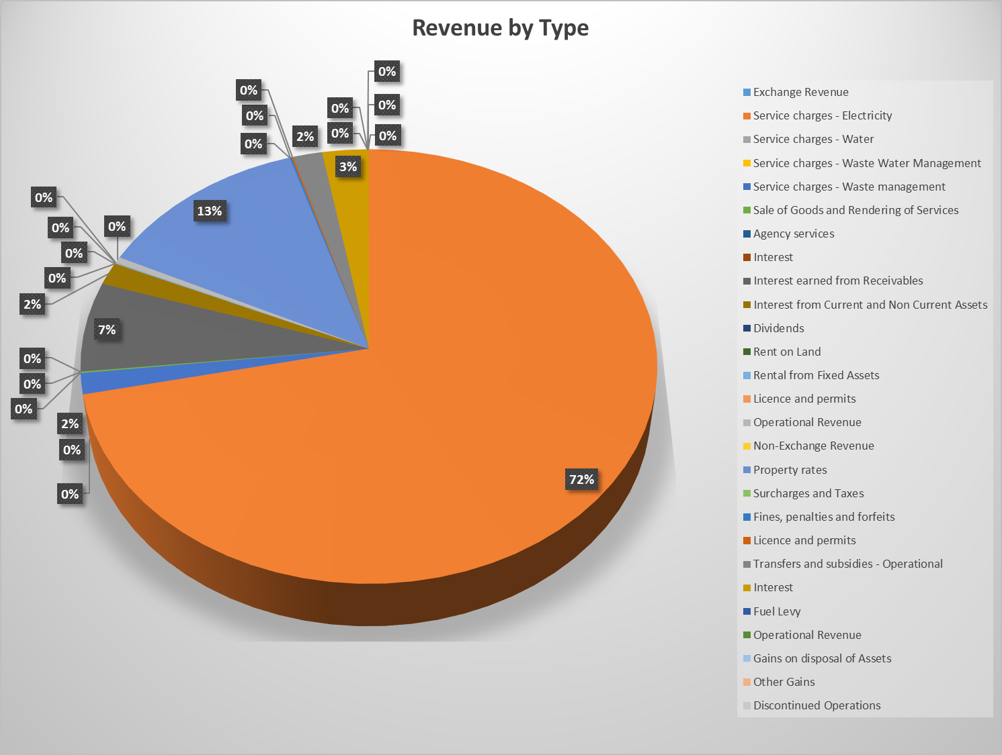

From the pie chart above we can see that we have biggest sources of income being Service Charges-Electricity Revenue 72% followed by Property rates at 13% as at the end of December 2023.

Table 2: Operating Expenditure as at the end of December 2023.



The table above gives us a picture of the expenditure incurred as at the end of December 2023. Total expenditure this month is 20.8 million. Bulk Purchases- Electricity are the highest at 18.6 million.

Operating Expenditure has an overall variance of 18% below the budgeted year-to-date amount of 378- million and that can mainly be attributed to the following:

* Employee related costs shows a negative figure for the month due to the adjustment that was processed to correct overstatement from the previous month.
* Remuneration of councillors also shows a variance of 51% above the budgeted amount and that can be attributable to the fact that the municipality had to adjust the remuneration from grade 3 to 4 and also pay back pays for 18 months.
* Debt Impairment, Depreciation and irrecoverable debts, the municipality records -100% variance on this items due to the fact that their calculation is only effected at year end.
* Irrecoverable debts written off shows a variance of 100% less when year-to-date actual is measured against the year-to-date budget and that is mainly attributable to the fact that the calculation is also done at year end.
* Contracted Services recorded a 23% variance above the budgeted year-to-date figure mainly due the fact that the biggest chunk of this item is consultant fees which is mainly used for the preparation of AFS as well as the external audit which the municipality is busy with currently.

**Figure 2: Expenditure**

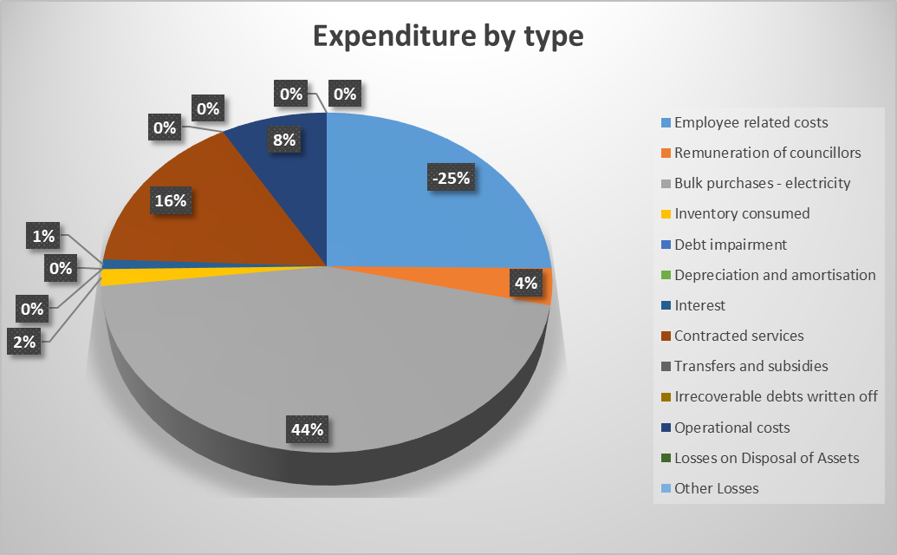

At Bulk purchases at 44% employee related are the highest as at the end of December 2023.

**Section 66 Report**



Employee related costs for the month of December 2023 at 16.6 million and councillors remuneration at 1.5 million. Total salary costs amount to 18.1 Million.

**2.2 INVESTMENTS**

The investments include all the unspent conditional grants and current year receipts that are ring fenced. Below is a table that details all the investments as at the end of December 2023:

Table 2 : Investments





**2.3 GRANT REGISTER**

The funds received so far are 152.9 million and funds spent are sitting at 128.5 million as at December 2023.

**2.4** **CREDITORS AGE ANALYSIS**



The municipality has paid off almost all of its creditors. The total outstanding as at December 2023 is 31 thousand as we can see from the above table.

**2.5.1 Top 20 Paid Creditors**



**2.6 DEBTORS AGE ANALYSIS**

Table: Debtors Age Analysis



Total debtors are at 527 million and have increased from November 2023 being 488.7 million, debtors over 90 days remained at 438 million.

**2.7 CASH COVERAGE**



*Budget Tables*





**3. RECOMMENDATION**

That the contents of this report be noted.

**MUNICIPAL MANAGER’S QUALITY CERTIFICATE**

I, SB Mthembu, the Municipal Manager of Inkosi Langalibalele Local Municipality, hereby certify that: -

* The monthly budget statements,
* Monthly Budget Monitoring Report (Section 71 of MFMA)

For the month of DECEMBER 2023**,** has been prepared in accordance with the MFMA and its Regulations made under the Act.

**Name:Mr S.B Mthembu**

**Municipal Manager of Inkosi Langalibalele Local Municipality**

**Signature: _______________________**

## Date: ___________________________